**Lesson 4 Demo 7**

**Merging Branches in Git**



Steps to be followed:

1. Create a new branch
2. Create a new file in the new branch
3. Switch to the main branch
4. Merge the branches
5. Push the changes to the remote repository

**Note:** A **projectfile** is already created in Lesson 4 Demo 5. If you do not have the repository, first perform that demo and then execute the steps from this demo.

**Step 1: Create a new branch**

1.1 Open the Terminal in your lab, and navigate to the sample-repository folder

**cd projectfile**

1.2 Execute the following command on the terminal to create a new branch:

***git branch sample_branch***

***git branch***

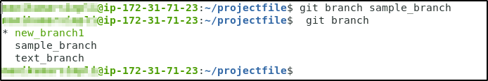

**Step 2: Create a new file in the sample_branch**

2.1 Use the following command to switch to the sample_branch:

***git checkout sample_branch***

2.2 Use the following commands to create an empty HTML file **index1.html,** and add it to the test_branch:

***touch index1.html***

***git add index1.html***

***git commit -a -m "index1.html added to the sample_branch"***

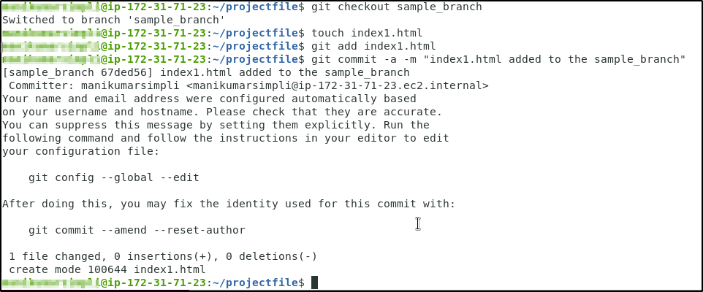

**Step 3: Switch back to the main branch**

3.1 Use the following command to switch back to the main branch:

***git checkout new_branch1***

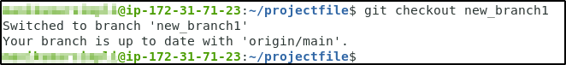

**Step 4: Merge the branches**

4.1 Use the following command to merge the sample_branch to the main branch:

***git merge sample_branch***

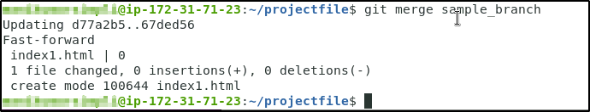

**Step 5: Push the changes to the remote repository**

5.1 Use the following command to push the new_branch1 to the remote repository:

***git push -u origin new_branch1***

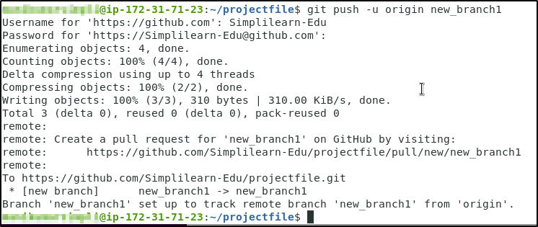

5.2 Go to the remote repository to check whether the branch is updated

